Expensify registration

Added 02.07.2018.

To use the API of Expensify, you will need to generate API credentials.

1. Create an Expensify account at <https://www.expensify.com/>.

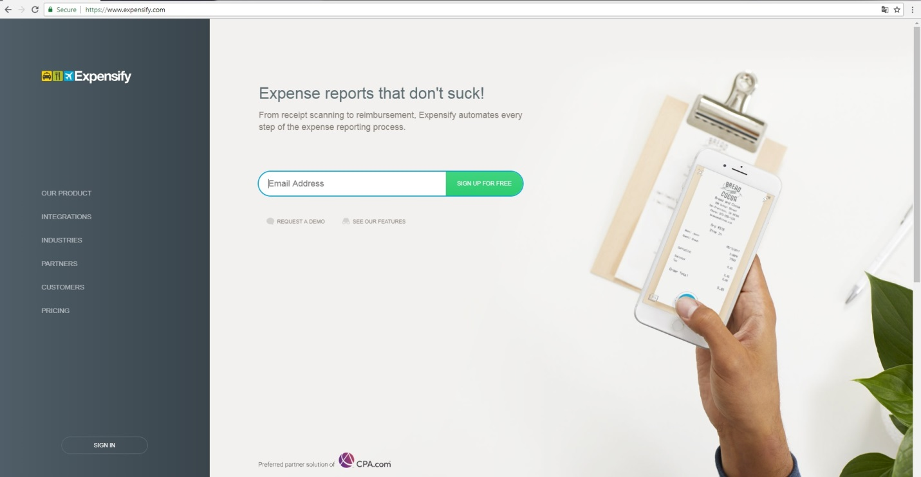

1. Enter your e-mail and enter Sign Up.

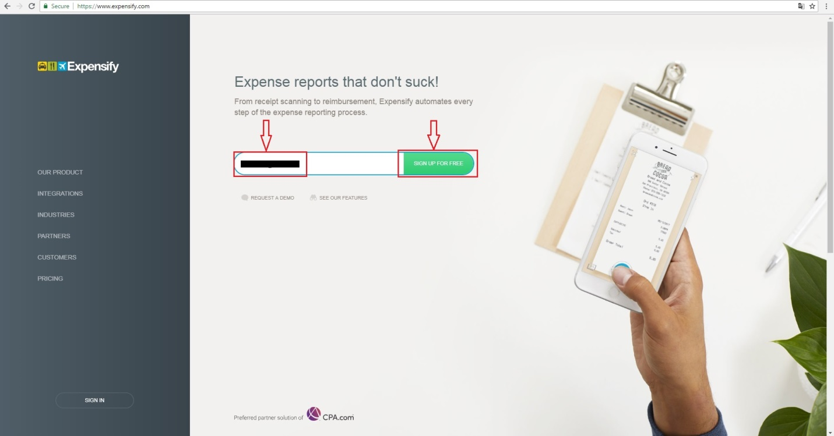

1. You need to confirm your e-mail address in e-mail letters, which arrived in your e-mail inbox.

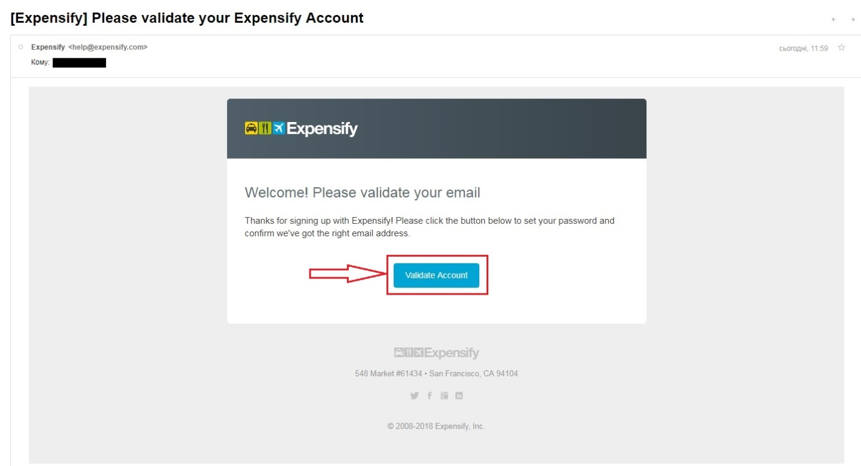

1. After confirmation your e-mail address you need to set up your password for Expensify account.

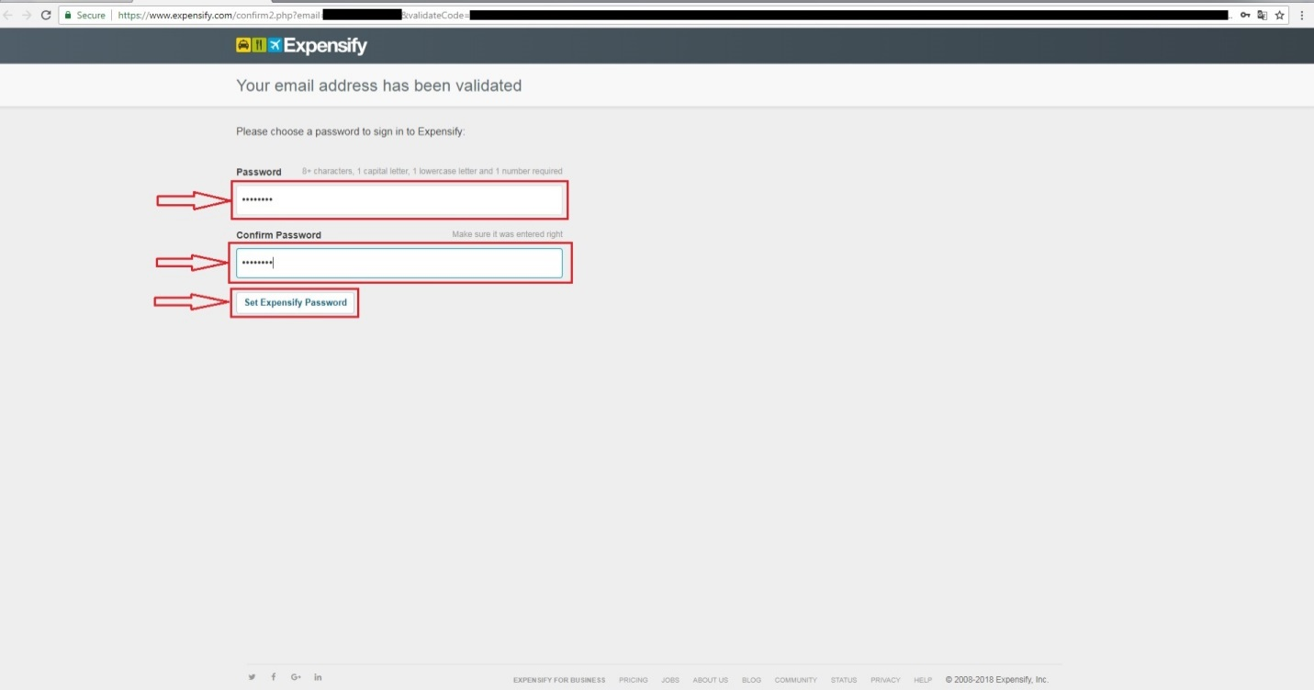

1. After set up your password you redirect in your Expensify account.

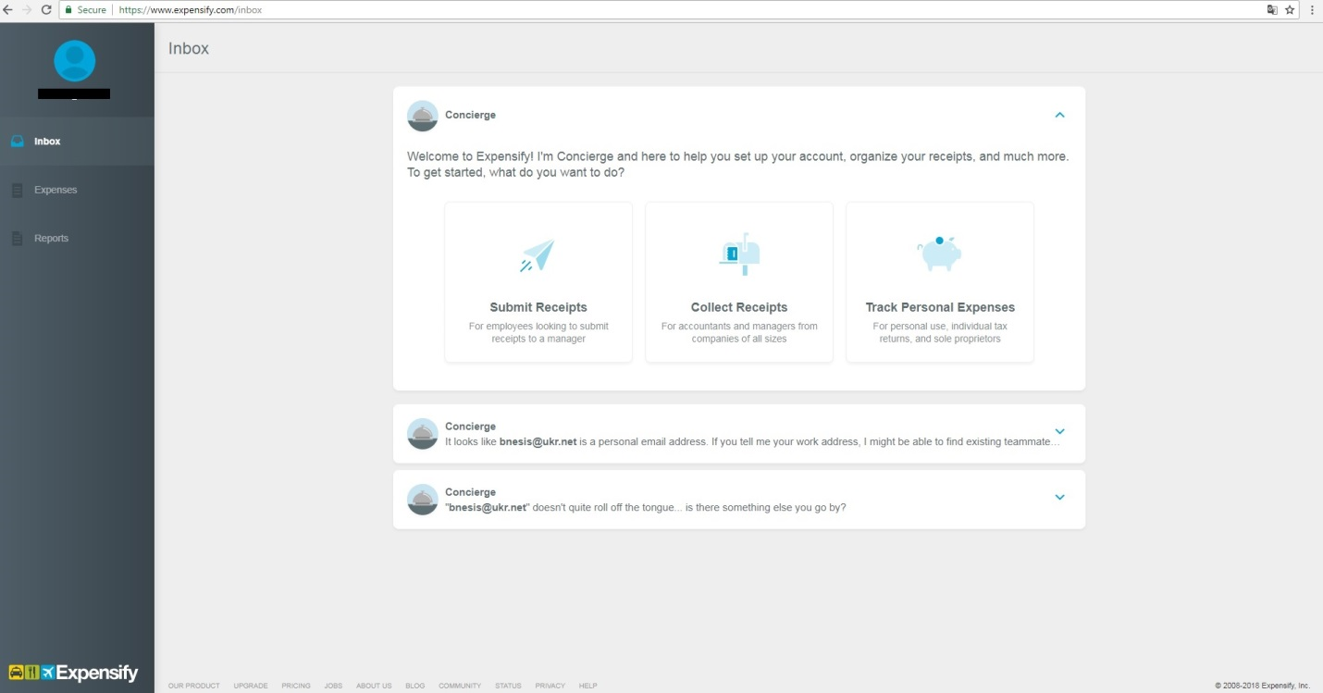

1. For get a credentials (partnerUserID and partnerUserSecret) go to <https://www.expensify.com/tools/integrations/> and click “Click here”.

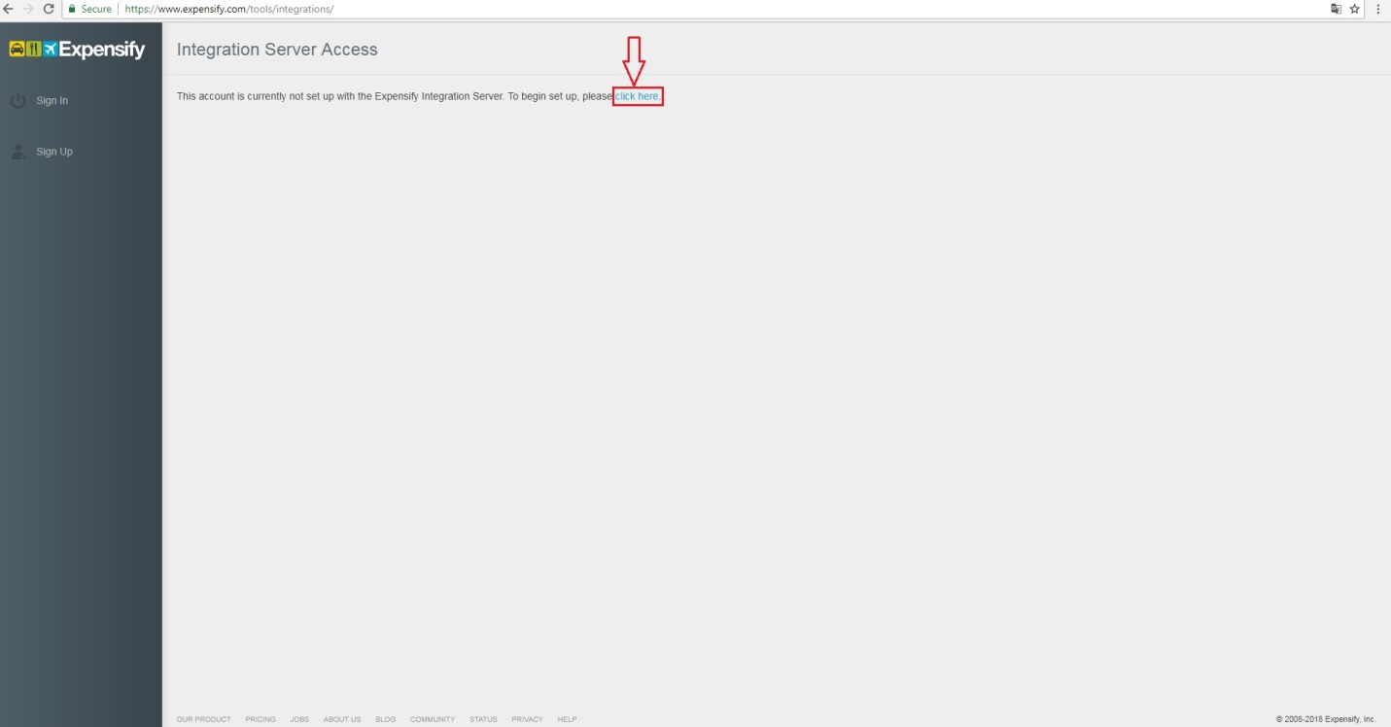

1. A pair of credentials (partnerUserID and partnerUserSecret) will be generated and shown on the page. Make sure to store the partnerUserID and partnerUserSecret pair you’re given in a secure location, as you won’t be shown them again.

